VA Benefits and Eligibility Tracking System
Forest Wadsworth
CST-451 Capstone Project Requirements Document
Grand Canyon University
Instructor: Professor Mark Reha
Revision: 1.0
Date: May 15, 2026

ABSTRACT

This project focuses on the requirements analysis for a web-based VA Benefits Eligibility and Tracking System designed to help users understand and manage simulated veterans’ benefits information through a centralized platform. The proposed system allows users to securely authenticate, enter service-related information, receive simulated eligibility determinations, and monitor claim statuses through a structured dashboard interface. The broader goal of the project is to improve usability and organization by consolidating benefits eligibility and tracking functions into a single web application.
The Requirements Analysis phase defined the system’s functional and non-functional requirements, technical requirements, logical architecture, user interface designs, and reporting structure. Functional requirements established core system behavior including user authentication, service information submission, eligibility processing, dashboard viewing, and claim tracking. Non-functional requirements addressed important quality attributes such as security, usability, reliability, maintainability, and browser compatibility. The technical analysis identified planned technologies including Java, Spring Boot, MySQL, REST APIs, and standard web technologies to support application development.
This milestone accomplished the creation of a structured requirements specification that will guide future design and development phases of the project. Logical system models, interface layouts, and reporting concepts were developed to define information flow, user interaction, and system organization. The completed requirements document provides a clear blueprint for building a functional prototype while supporting sound software engineering practices, scope management, and system planning.

History and Signoff Sheet
Change Record
Date | Author | Revision Notes
 |  | Initial draft for review/discussion

Overall Instructor Feedback/Comments

Overall Instructor Feedback/Comments
Integrated Instructor Feedback into Project Documentation
☐ Yes ☐ No

TABLE OF CONTENTS
Functional Requirements 4
Non-Functional Requirements 5
Technical Requirements 6
Logical System Design 7
User Interface Design 8
Reports Design 9

Functional Requirements
Use Cases
The VA Benefits Eligibility and Tracking System will allow users to securely access a centralized platform to determine simulated VA benefits eligibility and track claim status information. The system will process user-provided service information and display eligibility results through a structured dashboard interface.
The following functional user stories describe the primary actions performed by the system:
ID | User Story | Priority
FR-1 | As a user, I want to create an account so that I can securely access the system. | High
FR-2 | As a user, I want to log in using authenticated credentials so that my information remains protected. | High
FR-3 | As a user, I want to enter service-related information so that the system can determine simulated VA benefits eligibility. | High
FR-4 | As a user, I want the system to evaluate my information using predefined eligibility rules so that I can view potential benefits. | High
FR-5 | As a user, I want to view my eligibility results on a dashboard so that I can easily understand available benefits. | High
FR-6 | As a user, I want to track claim statuses so that I can monitor the progress of submitted claims. | Medium
FR-7 | As a user, I want my data stored in a database so that my information is retained between sessions. | High
FR-8 | As a user, I want to update my service-related information so that my eligibility results remain accurate. | Medium
FR-9 | As a user, I want to securely log out so that unauthorized users cannot access my account. | High
FR-10 | As a developer, I want the system to validate user input so that invalid or incomplete data is not processed. | High

Functional Use Case Descriptions
Use Case: User Login
Item | Description
Primary Actor | User
Description | Allows users to authenticate and access the system dashboard.
Preconditions | User account exists in the database.
Main Flow | User enters username and password → System validates credentials → Dashboard is displayed.
Postconditions | User session is created and access is granted.

Use Case: Submit Service Information
Item | Description
Primary Actor | User
Description | Allows users to enter military service-related information for eligibility evaluation.
Preconditions | User is authenticated.
Main Flow | User completes service information form → System validates entries → Information is stored in the database.
Postconditions | Service information is available for eligibility processing.

Use Case: View Eligibility Results
Item | Description
Primary Actor | User
Description | Displays simulated VA benefits eligibility results based on user-provided information.
Preconditions | Service information has been submitted.
Main Flow | System processes eligibility rules → Dashboard displays benefits results.
Postconditions | User can review available simulated benefits.

Use Case: Track Claim Status
Item | Description
Primary Actor | User
Description | Allows users to monitor the status of simulated claims.
Preconditions | User is logged into the system.
Main Flow | User accesses dashboard → System retrieves claim data → Status information is displayed.
Postconditions | User can review claim progress information.
Functional Requirements Removed from Scope
At the current stage of development, no functional requirements or user stories have been removed from scope.
Use Case or User Story | Approval Date | Justification
None | N/A | No functional requirements have been removed from scope at this time.

Non-Functional Requirements
Use Cases
The non-functional requirements define the quality attributes and operational standards of the VA Benefits Eligibility and Tracking System. These requirements focus on system security, usability, performance, reliability, maintainability, and scalability to ensure the application functions effectively and provides a positive user experience.
The following non-functional use cases describe the expected operational behavior of the system:
NFR ID | Non-Functional Requirement | Description
NFR-1 | Security | The system shall require authenticated login credentials before granting access to protected features and user data.
NFR-2 | Data Protection | The system shall securely store user account and service-related information within the database.
NFR-3 | Input Validation | The system shall validate all user input to prevent incomplete or invalid data submissions.
NFR-4 | Usability | The system shall provide a simple and organized user interface that is easy to navigate.
NFR-5 | Performance | The system shall display dashboard and eligibility results within a reasonable response time under normal usage conditions.
NFR-6 | Reliability | The application shall maintain consistent functionality without major system crashes or failures.
NFR-7 | Maintainability | The application shall utilize modular code structure to simplify future updates and maintenance.
NFR-8 | Availability | The system shall remain accessible during normal development and testing periods.
NFR-9 | Scalability | The system design shall allow future expansion of eligibility categories and dashboard features.
NFR-10 | Compatibility | The web application shall function on modern desktop web browsers such as Chrome, Edge, and Firefox.

Non-Functional Use Case Descriptions
Use Case: Secure Authentication
Item | Description
Primary Actor | User
Description | Ensures that only authenticated users can access protected system features.
Preconditions | User account exists in the database.
Main Flow | User enters credentials → System validates account information → Access is granted.
Postconditions | Secure authenticated session is created.

Use Case: Input Validation
Item | Description
Primary Actor | User
Description | Ensures all required fields and valid formats are entered before processing data.
Preconditions | User accesses an input form.
Main Flow | User submits form → System validates entries → Errors displayed if invalid → Valid data accepted.
Postconditions | Only valid information is processed and stored.

Use Case: Browser Compatibility
Item | Description
Primary Actor | User
Description | Ensures the application functions correctly across supported web browsers.
Preconditions | User accesses the system using a supported browser.
Main Flow | User opens application → System interface renders correctly → Features operate normally.
Postconditions | User can consistently use the application regardless of browser choice.

Non-Functional Requirements Removed from Scope
At the current stage of development, no non-functional requirements or user stories have been removed from scope.
Use Case or User Story | Approval Date | Justification
None | N/A | No non-functional requirements have been removed from scope at this time.

Technical Requirements
Use Cases
The VA Benefits Eligibility and Tracking System will utilize modern web application technologies to support user authentication, eligibility processing, database management, and dashboard functionality. The selected technologies are intended to provide a secure, maintainable, and scalable foundation for the application while remaining appropriate for the project scope and timeline.
TR ID | Technology or Tool | Description
TR-1 | Java | Primary programming language used for backend application development and business logic implementation.
TR-2 | Spring Boot | Framework used to simplify backend development, REST API creation, dependency management, and application configuration.
TR-3 | MySQL | Relational database management system used to store user accounts, service information, and simulated claim data.
TR-4 | HTML/CSS | Technologies used to design and structure the user interface of the web application.
TR-5 | JavaScript | Used to provide interactive frontend functionality and dynamic user interface behavior.
TR-6 | REST APIs | Used to enable communication between frontend and backend application components.
TR-7 | GitHub or GitLab | Version control platform used to manage source code, track revisions, and organize project tasks.
TR-8 | IntelliJ IDEA or VS Code | Integrated Development Environment (IDE) used for application development and debugging.
TR-9 | Maven | Build and dependency management tool used within the Spring Boot project environment.
TR-10 | Web Browser Testing Tools | Used to test application functionality, responsiveness, and compatibility across supported browsers.

Technical Environment Requirements
Component | Requirement
Operating System | Windows 10 or later
Internet Access | Required for dependency downloads, repository management, and testing
Web Browser | Google Chrome, Microsoft Edge, or Mozilla Firefox
Database Server | MySQL Server
Development Environment | Java Development Kit (JDK 17 or later)
Framework Support | Spring Boot framework dependencies

Technical Use Case Descriptions
Use Case: Backend Processing
Item | Description
Primary Actor | System
Description | Processes user requests, eligibility logic, and database interactions using Spring Boot and Java.
Preconditions | Application server and database are running.
Main Flow | User submits request → REST controller processes request → Service layer executes logic → Database interaction occurs → Response returned to frontend.
Postconditions | User receives processed application data successfully.

Use Case: Database Storage
Item | Description
Primary Actor | System
Description | Stores and retrieves user information and simulated claim data using MySQL.
Preconditions | Database connection is active.
Main Flow | System receives data → Data validated → Information stored in relational database tables → Data retrieved when requested.
Postconditions | User information is securely retained and accessible.

Use Case: Version Control Management
Item | Description
Primary Actor | Developer
Description | Tracks project revisions and manages source code using GitHub or GitLab.
Preconditions | Repository has been initialized.
Main Flow | Developer updates code → Changes committed → Repository synchronized and tracked.
Postconditions | Project changes are version-controlled and documented.

Technical Requirements Removed from Scope
At the current stage of development, no technologies or technical requirements have been removed from scope.
Technology or Tool | Approval Date | Justification
None | N/A | No technologies or technical requirements have been removed from scope at this time.

Logical System Design
The logical design of the VA Benefits Eligibility and Tracking System illustrates how information flows throughout the application and how the primary system components interact. The system is designed as a web-based application that allows users to authenticate, submit service-related information, process simulated eligibility rules, and view eligibility results and claim statuses through a centralized dashboard.
The logical architecture separates the application into frontend, backend, business logic, and database layers to improve organization, maintainability, and scalability.

Logical System Components
Component | Description
User Interface Layer | Provides the frontend web pages and dashboard that allow users to interact with the system.
Authentication Module | Validates user login credentials and manages secure user sessions.
Eligibility Processing Module | Processes user service-related information using predefined eligibility rules.
Claim Tracking Module | Displays and updates simulated claim statuses for the user dashboard.
Service Layer | Handles business logic and communication between controllers and the database layer.
Database Layer | Stores user accounts, service information, eligibility results, and claim status data.

Logical System Flow
- User accesses the application through a web browser.
- User logs into the system using authenticated credentials.
- System validates login information against stored account data.
- User submits service-related information through the input form.
- System validates and processes the submitted information.
- Eligibility rules are evaluated using backend business logic.
- Results are stored in the database.
- Dashboard displays eligibility results and claim tracking information.
- User may update information or log out securely.

Logical Architecture Diagram

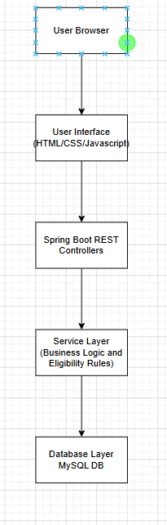

Data Flow Description
Source | Process | Destination
User Login Input | Authentication Validation | User Dashboard
Service Information Form | Eligibility Processing | Eligibility Results
Claim Status Data | Dashboard Retrieval | User Dashboard
User Updates | Database Storage | Updated User Records

System Design Considerations
- The application will follow a layered architecture to separate frontend, backend, and database responsibilities.
- REST APIs will facilitate communication between the user interface and backend services.
- The system will utilize modular components to simplify future maintenance and scalability.
- Simulated eligibility rules will remain intentionally simplified to maintain project scope and timeline requirements.
- Database normalization principles will be applied to reduce redundant data storage and improve consistency.

User Interface Design
The VA Benefits Eligibility and Tracking System will provide a web-based user interface designed for clarity, usability, and simple navigation. The interface will allow users to securely access the application, submit service-related information, view eligibility results, and monitor claim statuses through a centralized dashboard.
Sitemap
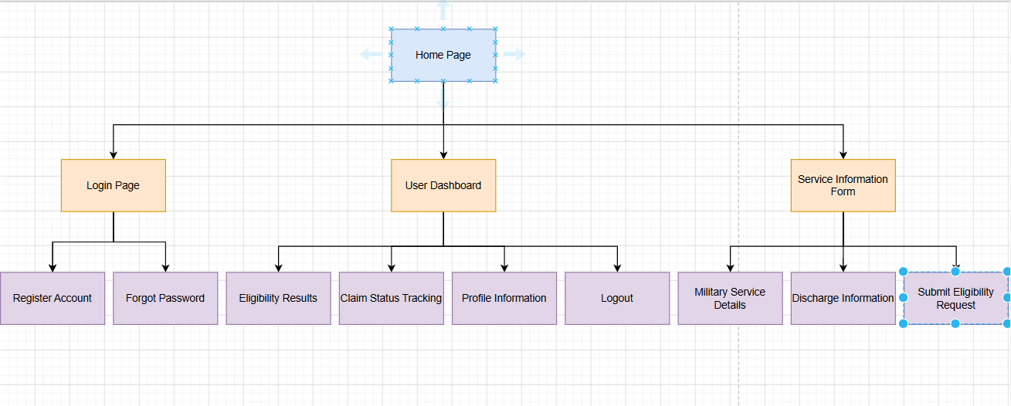

Screen 1 – Login Screen

Purpose
Allows users to securely authenticate and access the system dashboard.

Draft Layout
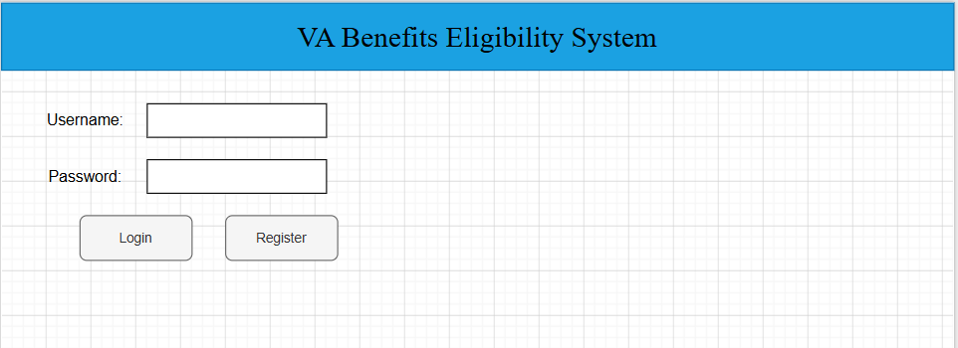

Interface Components
Component | Description
Application Title | Displays system name.
Username Field | Accepts username input.
Password Field | Accepts secure password entry.
Login Button | Authenticates user credentials.
Register Button | Directs user to account creation page.

Screen 2 – User Dashboard

Purpose

Displays simulated eligibility results, claim statuses, and navigation options.

Draft Layout
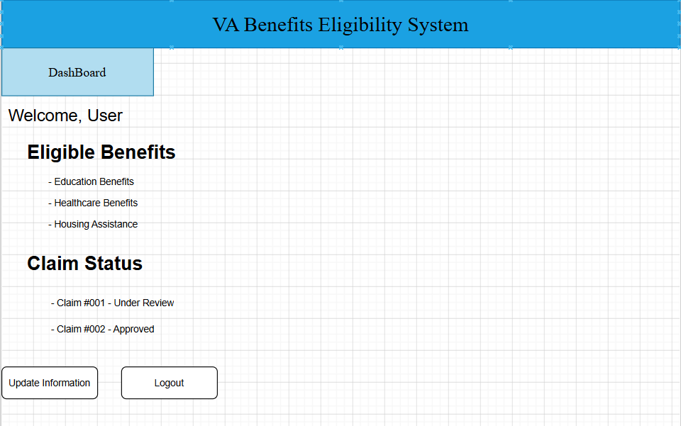

Interface Components
Component | Description
Welcome Banner | Displays logged-in user greeting.
Benefits Panel | Displays eligibility results.
Claim Status Panel | Displays simulated claim tracking information.
Update Button | Opens service information update form.
Logout Button | Ends authenticated session securely.

Screen 3 – Service Information Form

Purpose
Allows users to submit military service information for eligibility processing.

Draft Layout
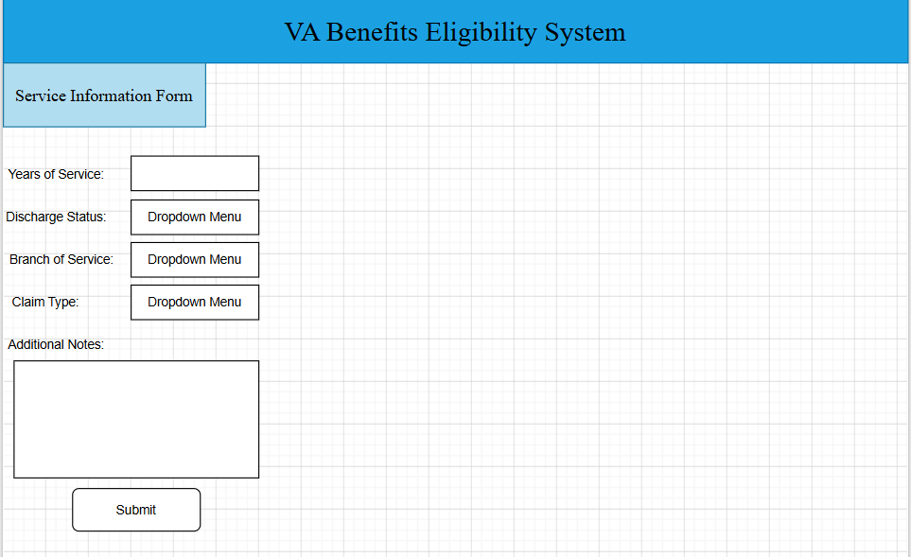

Interface Components
Component | Description
Input Fields | Capture military service details.
Dropdown Menus | Standardize selection options.
Notes Section | Allows optional supporting information.
Submit Button | Sends information for eligibility evaluation.

User Interface Design Considerations
- The interface will emphasize simplicity and ease of navigation.
- Consistent layout and styling will be maintained across screens.
- Forms will include validation to reduce user input errors.
- Responsive design principles will be considered for compatibility across different screen sizes.
- Clear labels and organized content sections will improve usability and readability.

Reports Design
The VA Benefits Eligibility and Tracking System does not generate formal business reports in the traditional sense. Instead, the system focuses on presenting eligibility determinations and claim tracking information dynamically through the user dashboard interface. Because the application is designed as an interactive web platform using simulated data, dashboard views and eligibility summaries serve as the primary method of reporting information to users.

Dashboard Report – Eligibility Summary

Purpose
Displays simulated VA benefits eligibility results based on user-provided service information.
Display Value | Variable or Field | Format Notes
User Name | User.username | Text
Years of Service | ServiceInfo.yearsOfService | Numeric Value
Discharge Status | ServiceInfo.dischargeStatus | Text / Dropdown Value
Eligible Benefits | EligibilityResult.benefitList | List Format
Eligibility Status | EligibilityResult.status | Eligible / Not Eligible

Frequency
Generated dynamically each time the user accesses the dashboard or submits updated service information.

Dashboard Report – Claim Tracking Status

Purpose
Provides users with a simplified view of simulated claim progress and current status information.
Display Value | Variable or Field | Format Notes
Claim ID | Claim.claimID | Numeric / Identifier
Claim Type | Claim.claimType | Text
Claim Submission Date | Claim.submitDate | MM/DD/YYYY
Claim Status | Claim.status | Pending, Under Review, Approved, Denied
Last Updated | Claim.lastUpdated | MM/DD/YYYY

Frequency
Displayed dynamically when the user logs into the dashboard or refreshes claim information.

Supplemental Documentation – Eligibility Processing Overview
Since the application uses simulated business rules rather than generating downloadable reports, the following process visualization summarizes the system’s eligibility workflow.
User Login
↓
Submit Service Information
↓
Validate User Input
↓
Process Eligibility Rules
↓
Store Results in Database
↓
Display Dashboard Results
↓
Track Claim Status

Reporting Design Considerations
- Reports are presented through a dynamic dashboard rather than exported documents.
- Information displayed to users is generated from simulated eligibility and claim data.
- Dashboard summaries are designed for readability and quick access to key information.
- Future enhancements could include downloadable PDF summaries, historical claim reports, or administrative analytics dashboards.
- Because the project uses simulated data, reports are intended for demonstration purposes only.

